RECORD OF CONTROL MEASUREMENT
OUTDOOR FACILITIES MEASUREMENT - DOUBLE BEND

This form must be sent to: technicalofficer@worldathletics.org

3. Length of the Track – Record of Control Measurement - Double Bend Track

For Double Bend tracks, as illustrated in the Manual, the bends are to be subdivided into the different radius sectors such that measurements for both radii are taken where the radii coincide.

In the case of standard double bend tracks shown in the Manual:
Manual Figure | Segment Length  Small Radius | Number of Measurements | Segment Length  Large Radius | Number of Measurements
1.2.3b (34/51.543m) | 41.539m | 4 | 35.984m | 4
1.2.3c (24/48m) | 25.133m | 4 | 50.265m | 8
1.2.3d (27.082/40.022m) | 25.052m | 4 | 51.690m | 8

The record of control measurement and calculation of length should be adapted for other double bend configurations by dividing the arcs into a different number of segments so that the length of each bend arc is approximately equal, but the number of measurements per segment should not be less than four.

3.1. Dimensional Accuracy of the 400m Double Bend Track
The dimensional accuracy is measured on the outside edge of the inner line of each lane.
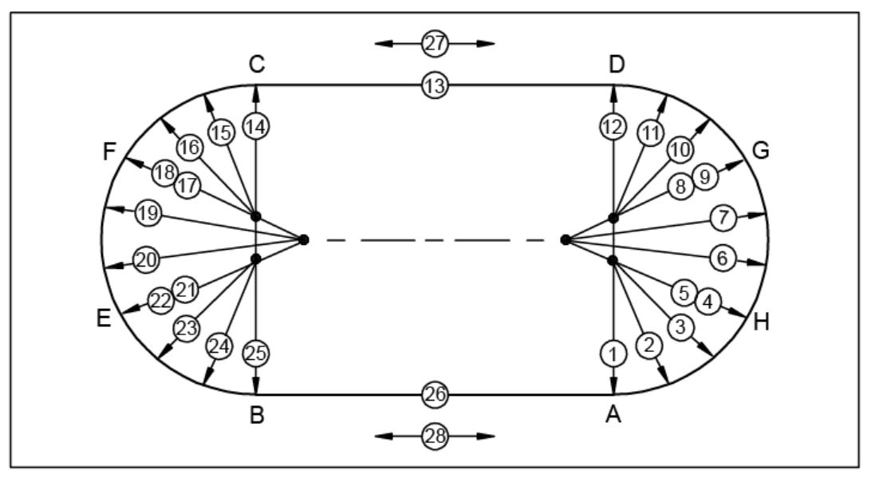
Example of the control measurement of 400m Double Bend Track (based on 1.2.3b)

N° | Angle | Lane 1 |  | Lane 2 |  | Lane 3 |  | Lane 4 |  | Lane 5 |  | Lane 6 |  | Lane 7 |  | Lane 8 |  | Lane 9
 |  | R₁ = m |  | R₂ = m |  | R₃ = m |  | R₄ = m |  | R₅ = m |  | R₆ = m |  | R₇ = m |  | R₈ = m |  | R₉ = m
 |  | L | D | L | D | L | D | L | D | L | D | L | D | L | D | L | D | L | D
 | gon | m | mm | m | mm | m | mm | m | mm | m | mm | m | mm | m | mm | m | mm | m | mm
1 | 0.000
2
3
4
Averaged | 1-4
5
6
7
8
Averaged | 5-8
9
10
11
12 | 200.000
Averaged | 9-12
× π

14 | 0.000
15
16
17
Averaged | 14-17
18
19
20
21
Averaged | 18-21
22
23
24
25 | 200.000
Averaged | 22-25
× π
Note: The average radii shall be recorded to four decimal places.
13 | S
26 | S
27 | A
28 | A

3.2. Calculation of the Length (Inside Border) – Double Bend Tracks

Length
The bend lengths and length deviations shall be calculated to three decimal places using bend average radii and differences to four decimal places.
Lane 1 | Distance | Angle | Length
Average radius curve A - H | m | gon | m (+)
Average radius curve H - G | m | gon | m (+)
Average radius curve G - D | m | gon | m (+)
Average radius curve C - F | m | gon | m (+)
Average radius curve F - E | m | gon | m (+)
Average radius curve E - B | m | gon | m (+)
Straight C – D (13) | n/a | n/a | m (+)
Straight A – B (26) | n/a | n/a | m (+)
Length of the inside border | n/a | n/a | m (=)

Deviation from the running length
The deviation of the length of the inside border added to the planning length of the track from page 5 should also give the Theoretical Running Distance.
Lane 1 | Distance Deviation | Angle | Length Deviation
Average deviation from desired value A - H | m | gon | m (+)
Average deviation from desired value H - G | m | gon | m (+)
Average deviation from desired value G - D | m | gon | m (+)
Average deviation from desired value C - F | m | gon | m (+)
Average deviation from desired value F - E | m | gon | m (+)
Average deviation from desired value E - B | m | gon | m (+)
Straight C – D (13) | n/a | n/a | m (+)
Straight A – B (26) | n/a | n/a | m (+)
Length of the inside border | n/a | n/a | m (=)

