REPORT
OUTDOOR FACILITIES MEASUREMENT

This form must be sent to: technicalofficer@worldathletics.org
together with the application for one of the following:

CLASS 1 Certificate
A full certificate covering all technical aspects of the facility.
Measurement Report in accordance with the requirements of World Athletics and a Report of Synthetic Surface Field Test by an Accredited Laboratory in accordance with Rule 2 of the Technical Rules are required.
CLASS 2 Certificate
Measurement Report and current valid Product Certificate for the facility synthetic surfacing material are required.
CONFIRMATION OF COMPLIANCE
Measurement Report and the reasons why the full certification cannot be applied for are required.
Note: The technical requirements listed in the Track and Field Facilities Manual (“Manual”) on the World Athletics website also need to be met for the facility to be fit for the purpose.

NAME OF FACILITY:
City |  | Country
Address
GPS coordinates (finish line)
Latitude and longitude in decimal degree (DD) or in deg., min., sec. (DMS); elevation, if available.
SURVEY WORK
Company Name
Surveyor name |  | Email
Address
Start of survey |  | End of survey
Weather conditions |  | Temperature
Instruments
Theodolite |  | No.
Distance meter |  | No.
Last calibration date | Click or tap to enter a date.

General Notes

- For ease of distribution and handling, the report should be in Word document or pdf format. The measurements should be typed onto the form.
- Test methods are explained.
- Distances longer than 20m are to be measured by electro optical instruments.
- Angles are to be measured by theodolite.
- Provide and attach a Certificate of Instrument Accuracy for the instruments used in the survey, current at the time of the survey (less than one year old), that can be traced back to national and international standards of measurement.
- Levels to be provided in metres to three decimal places on separate forms.
- All the information required in this form must be determined by the surveyor, and he should not rely on any measurement work that may have been done by others.
- It is not for the surveyor or others to determine whether dispensations might be provided for any non-conformity with the Rules or the specification in the Manual. These are matters for World Athletics alone to determine. Certification will be delayed until the levels on the track, runways or landing areas conform. Therefore, non-conformities should be corrected before a submission is made.
- If there are more facilities than allowed for on the form, the same information as that requested should be provided for the extra facilities. This applies also to a back straight sprint track marked for competition.
- All measurements / calculations of length must be to the nearest mm.
- No negative tolerances are allowed in the measured distance of races.
- The surveyor must report any unusual situations not covered specifically by this proforma, that might affect the proper and safe conduct of a competition e.g. runways or track lanes which have extreme local lateral or overall inclinations, depressions or humps, bubbling or torn synthetic surface, loose or damaged kerbing.

GENERAL CONDITIONS

All tracks intended for use for international competition must conform to the stringent requirements for accurate measurement contained in Rules and, more specifically, in the Track and Field Facilities Manual.
The Measurement Report duly completed by a fully qualified surveyor is one of the requirements to issue CLASS 1 or CLASS 2 Athletic Facility Certificate.
Application for an Athletic Facility Certification may be made by an agent on behalf of the track owner but should be signed by the track owner as World Athletics will require an undertaking that any changes, (relining etc.) will be immediately notified to the Office.
Certificates issued under this scheme will normally be valid for five years. In the event of track remarking, World Athletics shall be informed, and a new Measurement Report must be provided.
All removable competition equipment such as hurdles, steeplechase hurdles, landing mats, stop boards, throwing cages have to be inspected before a competition and are not part of this Report. The same applies to the level of the sand in the horizontal jump landing pits and the level of the water in the steeplechase water jump.

OWNER OF FACILITY/STADIUM:
Address
City |  | Country
Email |  | Tel
Signature (scanned accepted) |  | Date | Click or tap to enter a date.

CONTENTS

General Notes 2

GENERAL CONDITIONS 2

FACILITY 4
A. Construction Category 4
1. Competition Arena 4
2. Warm-up Area 4

TRACK EVENTS 5
B. 400m Standard Track 5
1. Track - Design Dimensions 5
2. Track and Runway Surface 5
3. Length of the Track 6
4. The Incline of the Track 10
5. International Markings on the Track 11
C. Steeplechase Track 16
1. Track Details with Inside Water Jump 16
2. Track Details with Outside Water Jump 17
3. Steeplechase Hurdle Positions 18
4. Water Jump 18

FIELD EVENTS 19
D. Facilities for Jumping Events 19
1. Facility for High Jump 19
2. Facility for Pole Vault 19
3. Facility for Long Jump 20
4. Facility for Triple Jump 21
E. Facilities for Throwing Events 22
1. Facility for Shot Put 22
2. Facility for Discus Throw 23
3. Facility for Hammer Throw 24
4. Facility for Javelin Throw 25
F. Attachments 26
G. Conclusions 26

FACILITY

Construction Category

1. Competition Arena
Provide a layout drawing and photo of the facility in attachment. Please show a north point. For determining the Construction Category, a single runway would normally have landing areas or Pole Vault boxes at each end or at the centre. Based on the below information, the Construction Category will be determined during the review of the Measurement Report. Write the number of event facilities in the boxes below.
400m Standard Track |  | Y N | Other |  |  | m
Number of oval lanes |  |  | Number of straight lanes
Water jump for the Steeplechase |  | Y N | Inside Outside
Facility for Long and Triple Jump |  | total | Landing area | each end | one end | centre
Facility for High Jump
Facility for Pole Vault |  | total | Landing area | each end | one end | centre
Facility for Shot Put
Facility for Discus and Hammer Throw combined
Facility for Discus Throw only |  |  | Facility for Hammer Throw only
Facility for Javelin Throw
Permanent ancillary space at the competition arena  (e.g. for conditioning, physiotherapy, resting of athletes (Manual Chapter 4)) |  |  |  |  |  | m²
Full facilities for spectators (Indicate the number of spectators fully catered for)
Notes

2. Warm-up Area
Warm-up track provided |  |  |  |  |  | Y N
Surface of similar type to the main track |  |  |  |  |  | Y N
Track length m |  | No. of oval/straight lanes |  |  | o/ s
Jumping events HJ |  | PV |  | LJ | TJ
Throwing events separate field SP |  | DT |  | HT | JT
If there is no warm-up track, is an adjacent park or playing field available? |  |  |  |  |  | Y N
If yes, size
Permanent ancillary space at the warm up |  |  |  |  |  | m²
Notes

TRACK EVENTS

400m Standard Track

1. Track - Design Dimensions
Radius |  | m | Radii if double bend | m m m
Distance between Centre Points |  |  | m | Length of construction (planning size) at inside border | m
Nominal measuring length (length of Running Line) |  |  |  |  | m
Inner kerb |  |  | Height m | Width m
Kind of inside border (Kerb) (e.g. aluminium)
Number of oval lanes
Sprint lanes main side |  |  | Number | Length | m
Sprint lanes second side* |  |  | Number | Length | m
*If yes, please provide, on a separate sheet, levels and measurements for it to be incl. in the certificate.
Width of lanes (planning size) |  |  |  |  | m
The line on the right-hand side of each lane, in the direction of running, is included in the measurement of the width of each lane
Width of track (planning size) |  |  |  |  | m
Safety zone inside |  |  | m | Safety zone outside | m
If the safety zones inside and outside the track are individually less than 1 metre then the nature of the obstruction(s) should be described and photographs provided. The most obvious infield obstructions are likely to be a throwing safety cage or an inside steeplechase water jump.
Notes

2. Track and Runway Surface
See list : https://www.worldathletics.org/about-iaaf/documents/technical-information
Track surface product name
Name of manufacturer
Certification number |  |  | Absolute thickness | mm
Installation company
Address
Date of installation |  |  | Email
Line marking company
Line marker’s name |  |  | Date of marking
Notes

3. Length of the Track

3.1. Dimensional Accuracy of the 400m Standard Track
The dimensional accuracy is measured in the 28-point control readings on the outside edge of the inner line of each lane.
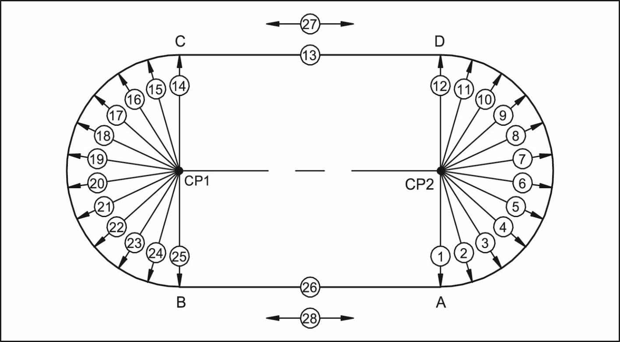
Record of 28-point control measurement:

L= Measured length of radii 1-12 and 14-25
R= Desired length of radii for each lane (R₁, R₂, R₃, …)
S= Measured length of the straights 13 and 26 (along each lane running line)
M= Desired length of each straight: is m
D= Deviation from desired value in millimetres (L-R), (S-M)
A= Measurements 27 and 28: alignment of the straights (the measured length of the straight at the kerb or inside white line edge compared with the measurement at the outside edge of the outer lane)

Permitted deviation from desired value for 1-26: 0.005m
Permitted deviation from alignment for 27 and 28: 0.01m
Permitted tolerance of the running length: +0.040m max.

(Record of Control Measurement for Double Bend tracks - see in a separate document on the website)

N° | Angle | Lane 1 |  | Lane 2 |  | Lane 3 |  | Lane 4 |  | Lane 5 |  | Lane 6 |  | Lane 7 |  | Lane 8 |  | (Lane 9)
 |  | R₁ = m |  | R₂ = m |  | R₃ = m |  | R₄ = m |  | R₅ = m |  | R₆ = m |  | R₇ = m |  | R₈ = m |  | R₉ = m
 |  | L | D | L | D | L | D | L | D | L | D | L | D | L | D | L | D | L | D
 | gon | m | mm | m | mm | m | mm | m | mm | m | mm | m | mm | m | mm | m | mm | m | mm
1 | 0.000
2 | 18.200
3 | 36.400
4 | 54.500
5 | 72.700
6 | 90.900
7 | 109.100
8 | 127.300
9 | 145.500
10 | 163.600
11 | 181.800
12 | 200.000
Averaged | 1-12
× π
14 | 0.000
15 | 18.200
16 | 36.400
17 | 54.500
18 | 72.700

19 | 90.900
20 | 109.100
21 | 127.300
22 | 145.500
23 | 163.600
24 | 181.800
25 | 200.000
Averaged | 14-25
× π
The average radii shall be recorded to four decimal places. (Value of π computer generated.)
If any “D” value exceeds ± 5mm then the lane width should be checked to ensure that it is 1.22m ± 0.01m.
13 | S
26 | S
27 | A
28 | A

3.2. Calculation of the Length (Inside Border)

Length
The bend lengths and length deviations shall be calculated to three decimal places using bend average radii and differences to four decimal places.
Lane 1 | Radial Measure | Angle | Length
Average radius curve A - D | m | 200.000 gon | m
Average radius curve C - B | m | 200.000 gon | m
Straight C – D (13) | n/a | n/a | m
Straight A – B (26) | n/a | n/a | m
Length of the inside border | n/a | n/a | m

Deviation from the running length
The deviation of the length of the inside border added to the planning length of the track from page 5 should also give the Theoretical Running Distance.
Lane 1 | Radial Measure Deviation | Angle | Length Deviation
Average deviation from desired value A - D | m | 200.000 gon | m
Average deviation from desired value C - B | m | 200.000 gon | m
Straight C – D (13) | n/a | n/a | m
Straight A – B (26) | n/a | n/a | m
Length of the inside border | n/a | n/a | m

3.3 Calculation of the Running Distance
Length of inside border | 200.000 | m (+)
Theoretical Running Line (at 0.30m) | 0.300 × π × 2 | 1.885m (+)
Theoretical Running Distance (TRD) |  | = m

3.4 Certification of the Length
Control of the inside lane running line length of track gives a length greater than 400m |  |  | Y N
The calculated difference of m (TRD-400m) is inside the permitted tolerance of +0.040m laid down in the Manual |  |  | Y N
The running line length of the inside lane was calculated at 0.30 metres outward from the outer edge of the kerb |  |  | Y N
The running line lengths of the other lanes were calculated at 0.20 metres outward from the outer edges of the lines |  |  | Y N
Direction of running is left-hand inside. Lanes are numbered with the left hand inside lane as 1 |  |  | Y N
Distance before 110m start line(s)* | m | Straight distance (run-out) after finish | m
*If < 3m before the 110m start for 1 or more lanes, provide a sketch showing the clearance for each lane.
If there is a 2nd straight, provide the distances achieved before the 110m start and after the finish line.

4. The Incline of the Track

Please use separate drawings (proformas to be used are available on the website) for providing the required spot levels.
It is essential that reduced levels not grades be provided at the intervals as requested on the proforma.
For ease of checking, it will assist if the level at the Finish Line is assumed to be 0.000m.
Test method: three check-points should be taken in a line: inside lane one, in the centre of the track and outside the outer lane. Levels need to be provided at 200m, at the Finish Line on the oval track, and at the 100m and 110m start in the main straight.
If there are sprint lanes on the second side, then levels and measurements must be provided for this additional sprint track for it to be included on the certificate.
If there are more straight sprint lanes than oval lanes, provide levels on the straight at the outside lane as well, on the lane corresponding to the number of oval lanes. This applies also to a back straight sprint track marked for competition.
The sign convention for World Athletics for the inclinations is that an upward inclination in the direction of running is positive.

4.1 Lateral Incline
The lateral inclination of the track is towards the inside lane | Y N
The lateral inclination of the track less than 1:100 (1.0%) | Y N

4.2 Overall Incline
The overall inclination of the track in the running direction from starts to finish is less than 1:1000 (0.1%) downwards | Y N

Notes

5. International Markings on the Track

5.1 General
All lanes are marked by white lines |  |  |  |  |  | Y N
All markings are 0.05m wide |  |  |  |  |  | Y N
All start lines (except for curved start lines) and the finish line are marked at right angles to the lane lines |  |  |  |  |  | Y N
The staggered starts for 800m events are marked so that the first bend has to be run in separate lanes. The position of the start lines and the arced green breakline 0.05m wide at the beginning of the following straight are as given in the Manual |  |  |  |  |  | Y N
The outer curved start lines for 1000m, 2000m, 3000m, 3000mSC (optional), 5000m and 10,000m are marked in a way that all competitors will run the same distance. A green mark 0.05m × 0.05m on the line between lanes 4 and 5 at the beginning of the following straight indicates where athletes starting in the outer group may join the runners of the inner group. |  |  |  |  |  | Y N
The 4 tangent points on the 2 straights, the points where the steeplechase curve meets a straight and the intersection of different radii curves on the steeplechase curve or double bend track are marked in a distinctive colour 0.05m × 0.05m on the white line of the inner lane |  |  |  |  |  | Y N
The following curved start lines are extended to the extent of the available synthetic:
1500m |  | Y N | 5000m | Y N | 10,000m | Y N
The 4 × 400m start lines are in accordance with the Manual (cf. 5.5 Int’l Relay Races) |  |  |  |  |  | Y N
Intersection of lane lines and finish line is painted black in a suitable design to assist alignment of the Photo Finish equipment and to facilitate the reading of the Photo Finish image |  |  |  |  |  | Y N
Immediately before the finish line, the lanes are marked with numbers with a minimum height of 0.50m read in the direction of running or from the outside of the track (optional) with the left-hand inside lane numbered 1 |  |  |  |  |  | Y N
White lines, 0.03m wide and 0.80m (0.40m at 2m) long, are marked 1m, 3m and 5m before the finish line (optional) |  |  |  |  |  | Y N
Notes

5.2 International Starts
The following international starts are marked on the track:

Races entirely or partly in separate lanes
100m | white | straight | In separate lanes | Y N
110m |  |  |  | Y N
200m |  | oval |  | Y N
400m |  |  |  | Y N
800m | white / green /white |  | In first bend in separate lanes | Y N
4 × 400m | white / light blue / white |  | three bends in separate lanes | Y N

Curved starts
800m | white | lane 1-8 | 2 full laps |  | Y N
2000m |  |  | 5 full laps |  | Y N
10,000m |  |  | 25 full laps |  | Y N
2000m | white | outer start lanes 5-8 | 5 full laps | first bend in L 5 | Y N
10,000m |  |  | 25 full laps |  | Y N
1000m | white | lane 1-8 | 2 full laps + 200m |  | Y N
3000m |  |  | 7 full laps + 200m |  | Y N
5000m |  |  | 12 full laps + 200m |  | Y N
1000m | white | outer start lanes 5-8 | 2 full laps + 200m | first bend in L 5 | Y N
3000m |  |  | 7 full laps + 200m |  | Y N
5000m |  |  | 12 full laps + 200m |  | Y N
1500m | white | lane 1-8 | 3 full laps + 300m |  | Y N
Mile | white | lane 1-8 | 4 full laps + 9.34m |  | Y N
2000m | white | lanes 1-8 | C. Steeplechase track |  | Y N
3000m |  |  |  |  | Y N
3000m |  | lanes 5-8 | (optional) |  | Y N

Notes

5.3 Start Measurement
All measurements shall be in metres (m) to three decimal places.
No negative tolerances are allowed in the measured distance of races. The deviation from the running length of all start lines must not exceed +0.0001 × L nor be less than 0.000m where L is the length of the race in metres.

All distances were measured in a clockwise direction from the edge of the finish line nearer to the start to the edge of the start line farther from the finish | Y N
The measurement of the curved start lines ensures that all runners start the same distance from the finish | Y N

Measured Distance to Finish Line
Start | Lane 1 | Lane 2 | Lane 3 | Lane 4 | Lane 5 | Lane 6 | Lane 7 | Lane 8 | (Lane 9)
100m
110m
200m
400m
800m
4 × 400m

If there are sprint lanes on the second side then measurements must be provided for this additional sprint track for it to be included on the certificate.

Measured Distance to Finish Line on the second side
Start | Lane 1 | Lane 2 | Lane 3 | Lane 4 | Lane 5 | Lane 6 | Lane 7 | Lane 8 | (Lane 9)
100m
110m

Measured Distance to Finish Line First Lap
Curved Start | Lane 1 | Lane 2 | Lane 3 | Lane 4 | Lane 5 | Lane 6 | Lane 7 | Lane 8 | (Lane 9)
1500m
1000m
3000m
5000m
800m
2000m
10,000m
1000m  3000m  3000mSC*  5000m | Outer start lane 5-8
2000m
10,000m
*optional

Notes

5.4 International Hurdle Events
Direction of running

The distances between the hurdles are measured from front to front of the marker.
For blue marks on blue coloured tracks, red colour should be used.

The following hurdle events are marked on the track and the measured distances to Finish Line (m):
Tolerance on hurdle distances ± 0.01 for 100m and 110m; ± 0.03 for 400m.
 | 10th | 9th | 8th | 7th | 6th | 5th | 4th | 3rd | 2nd | 1st
100mH
110mH
400mH

If there are sprint lanes on the second side then measurements must be provided for this additional sprint track for it to be included on the certificate.

The following hurdle events are marked on the 2nd side and the measured distances to Finish (m):
 | 10th | 9th | 8th | 7th | 6th | 5th | 4th | 3rd | 2nd | 1st
100mH
110mH

110m Hurdles (Men) | blue rectangle | 0.10m × 0.05m | Y N
100m Hurdles (Women) | yellow rectangle | 0.10m × 0.05m | Y N
400m Hurdles (Men / Women) | green rectangle | 0.10m × 0.05m | Y N

There are ten flights of hurdles marked in each lane. The distances between the hurdles in each lane are in accordance with the table in the Rule. | Y N
The markings are on the left and right side in each lane. Markings, sizes and colours are in accordance with the Manual Marking Plan. | Y N

Notes

5.5 International Relay Races
The following international relays are marked on the track and the measured distances to the finish are (m):
In the 4 × 100m relay, the 3rd runner scratch line and the 2nd runner scratch line in each lane correspond with the 200m and 300m starts respectively and, consequently, should have the same measurements.
For the blue marks on blue coloured tracks, red colour should be used.

4 × 100m Relay - Measured Distance to Finish
Takeover zone length 30m ± 0.02m, with the scratch line 20m from the start of the zone.
Takeover zone |  | Lane 1 | Lane 2 | Lane 3 | Lane 4 | Lane 5 | Lane 6 | Lane 7 | Lane 8 | (Lane 9)
4th | End: yellow line
 | Scratch line: white
 | Start: yellow line
3rd | End: yellow line
 | Scratch line: white
 | Start: yellow line
2nd | End: yellow line
 | Scratch line: white
 | Start: yellow line

The dimensions of the relay takeover zones are in accordance with the rule. | Y N
Marking sizes and colours are in accordance with the Manual Marking Plan. | Y N

4 × 400m Relay - Measured Distance to Finish
Takeover zone length 20m ± 0.02m, with the scratch line as centre.
The 2nd runner middle (scratch line) corresponds with the 800m start in each lane. For ease of compilation and checking, these measures may also be quoted as 800m measures.
Takeover zone |  | Lane 1 | Lane 2 | Lane 3 | Lane 4 | Lane 5 | Lane 6 | Lane 7 | Lane 8 | (Lane 9)
2nd runner | End: blue line
Middle: white
and green line
 | Start: blue line

All the first leg (first runner) and the first bend of the second leg (second runner) is run in separate lanes up to the breakline marked at the end of the first bend. | Y N
The dimensions of the relay takeover zones are in accordance with the rule. | Y N
Marking sizes and colours are in accordance with the Manual Marking Plan. | Y N

Notes

Steeplechase Track

1. Track Details with Inside Water Jump
If the water jump Steeplechase curve is kerbed, then the curve shall be measured 0.30m out from the curve, otherwise the curve is measured 0.20m out from the painted inside border.

The Steeplechase track has an inside kerb | 200.000 | Y N

Length / Angle |  | Measured
Radius of inner lane | R | m (=)
Theoretical running line of the track (distance from inside border) | L | m (=)
Theoretical running line of the Steeplechase track (distance from inside border) | l | m (=)
Axis (distance between Centre Points) | S | m (=)
Radius of Steeplechase track kerb / inside line | r | m (=)
Angle 1 Track | β | ⁰ (=)
Angle 2 Steeplechase | α | ⁰ (=)
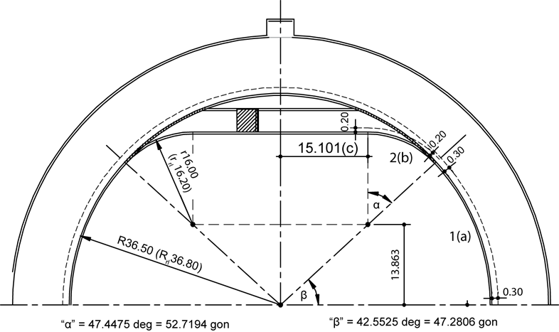
If the curve is not symmetrical, provide additional measure in the table above.

1.1 Calculation of the Steeplechase Lap (Water Jump Inside):
Length |  | Measured
Curve 1 (running track) | a | m (+)
Curve 2 (Steeplechase) | b | m (+)
Straight section to centre line | c | m (+)
Half steeplechase track (a+b+c) | z | m (=)
Full symmetrical Steeplechase track (2z) | d | m (=)
Curve D-A | e | m (+)
Straight A-B | f | m (+)
Straight C-D | g | m (+)
Steeplechase Lap (d+e+f+g) | h | m (=)

1.2 Steeplechase Start Positions (Water Jump Inside):
 | Theoretical | Measured | Difference | Location
2000m Steeplechase | 2000-5h= m | m | m | in front of A
3000m Steeplechase | 3000-7h= m | m | m | in front of A
Allow for an extra +0.02m margin when marking the starts.

2. Track Details with Outside Water Jump
If the water jump steeplechase curve is kerbed, then the curve shall be measured 0.30m out from the curve, otherwise the curve is measured 0.20m out from the painted inside border.
The Steeplechase track has an inside kerb | Y N

Length |  | Measured
Radius of inner lane | R | m (=)
Theoretical running line of the track (distance from inside border) | L | m (=)
Theoretical running line of the Steeplechase track (distance from inside border) | l | m (=)
Radius of Steeplechase track kerb / inside line | r | m (=)
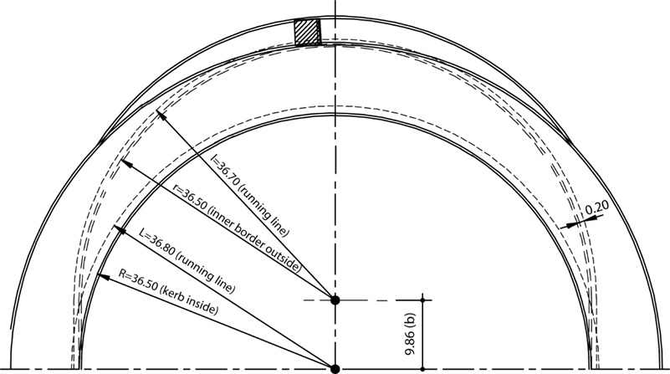

2.1 Calculation of the Steeplechase Lap (Water Jump Outside):
Length |  | Measured
Water jump curve | a | m (+)
Two transition straights | b | m (+)
Steeplechase track (a+b) | d | m (=)
Curve D-A | e | m (+)
Straight A-B | f | m (+)
Straight C-D | g | m (+)
Steeplechase Lap (d+e+f+g) | h | m (=)

2.2 Steeplechase Start Positions (Water Jump Outside):
 | Theoretical | Measured | Difference | Location
2000m Steeplechase | 5h-2000= m | m | m | after A
3000m Steeplechase | 3000-7h= m | m | m | in front of A
Allow for an extra +0.02m margin when marking the starts.

3. Steeplechase Hurdle Positions
The marked distance between the hurdle positions (ca. 1/5 of the length of the Steeplechase Lap):
Hurdle | 1-2 | 2-3 | 3-4 | 4-5 | 5-1
Water jump inside | m | m | m | m | m
Water jump outside | m | m | m | m | m
 |  | 3000mSC |  | 2000mSC
Finish line to 1st hurdle |  | m |  | n/a
5th hurdle to finish line |  | m |  | n/a
Start line to first hurdle jumped |  | m

4. Water Jump |  | Measured
Length including the hurdle |  | m
Width inside |  | m
Length inside pit a |  | m
Depth b |  | m
Floor length c |  | m
Slope Angle (tan⁻¹ b/(a-c)) |  | ⁰
Hurdle length |  | m
 |  | MEN | U18 MEN | WOMEN
Hurdle height |  | m | m | m
Notes
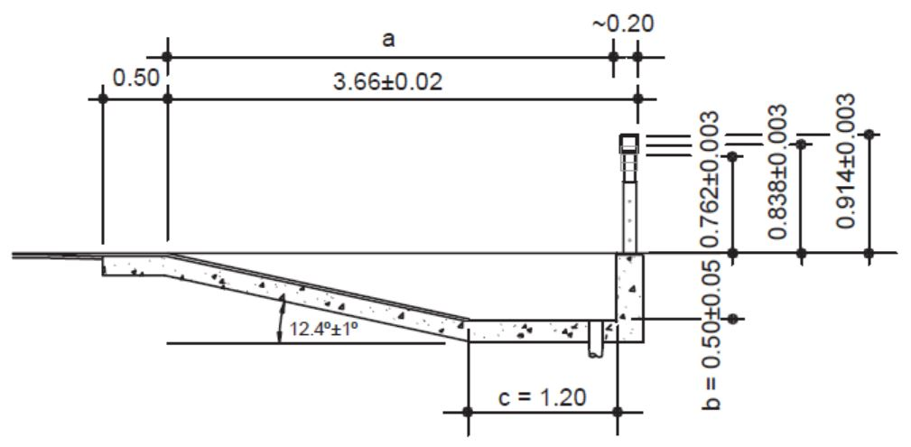
If the hurdle is not as shown above, e.g. the hurdle supporting posts are fixed directly to the face of the pit wall, then a sketch of the arrangement with dimensions must be provided.

FIELD EVENTS
Please use separate drawings (proformas to be used are available on the website) for providing the required spot levels. The Field Event facilities shall be identified by letters and numbers which coincide with those used in the Measurement Report and on the site plan for those facilities.
Provide reduced levels not grades on each of the runways at the intervals as requested on the proforma including all the take-off board(s), landing areas and at the planter boxes as appropriate.
For ease of checking, it will assist if the level on the pole vault box, take-off, throws circle and javelin throwing arc centre is assumed to be 0.000m.
The sign convention used by World Athletics for inclinations is that an upward inclination in the direction of running or throwing is positive. (For throws, at any radius, the lowest level is compared with the level at the centre of the appropriate throwing circle or javelin throwing arc to determine the inclination.)

Facilities for Jumping Events

1. Facility for High Jump (where there are two “D” areas and there are HJ mats on both “D”, then the two or more HJ facilities should be measured) |  | Area A | Area B
Runway | Length: | m | m
 | Does this length include part of the track? | Y N | Y N
Take-off area | It is level or the inclination complies with the rule | Y N | Y N
Inclination | The maximum overall inclination in the last 15m of the runway and take-off area is less than 1:167 (0.6%) in the direction of the centre of the crossbar | Y N | Y N
Provide runway radial levels at the centre of the take offs (0.000m) and 15m from the centre of each High Jump take off.

2. Facility for Pole Vault |  | Area A1 | Area B1 | Area A2 | Area B2
It is necessary that the questions for both ends of each runway be answered as the different direction of running could result in a different answer particularly regards the overall inclination in the direction of running.
Runway | Length: | m | m | m | m
 | Width: | m | m | m | m
 | It is marked by white lines 0.05m in width | Y N | Y N | Y N | Y N
 | There are marks beside the runway at each 0.5m between points 2.5m to 5m from the “0” line and at each 1m from 5m to 18m | Y N | Y N | Y N | Y N
Inclination | The maximum lateral inclination of the runway is less than 1:100 | Y N | Y N | Y N | Y N
 | In the last 40m of the runway, the overall downward inclination in the running direction is less than 1:1000 | Y N | Y N | Y N | Y N
Pole Vault box | Size, material and construction are in accordance with the rule | Y N | Y N | Y N | Y N
Zero line | A white line, 0.01m wide, is drawn at right angles to the axis of the runway, in line with the top back end of the box | Y N | Y N | Y N | Y N
Provide runway levels at the box (0.000m) and at 40m from each Pole Vault box.
3. Facility for Long Jump |  | Area A1 | Area B1 | Area A2 | Area B2
It is necessary that the questions for both ends of each runway be answered as the different direction of running could result in a different answer particularly regards the overall inclination in the direction of running.
Runway | Length: | m | m | m | m
 | Width: | m | m | m | m
 | It is marked by white lines 0.05m in width | Y N | Y N | Y N | Y N
Inclination | The maximum lateral inclination of the runway is less than 1:100 | Y N | Y N | Y N | Y N
 | In the last 40m of the runway, the overall downward inclination in the running direction is less than 1:1000 | Y N | Y N | Y N | Y N
Take-off board | It is in accordance with the rule | Y N | Y N | Y N | Y N
 | Distance between the take-off line and the far end of the landing area: | m | m | m | m
 | Distance between the take-off line and the nearer end of the landing area: | m | m | m | m
Landing area | Total width: | m | m | m | m
 | The axis of the runway is in line with the centre line of the landing area | Y N | Y N | Y N | Y N
Provide levels at each take-off board (0.000m), 40m from each Long Jump take-off board and at the landing area kerb four corners. If there are multiple horizontal jump runways using a common landing area that must have temporary taping during competition to limit the landing area width to 3.00m maximum, then additional levels shall be provided where the temporary taping will intersect the landing area surround.

Notes

4. Facility for Triple Jump |  |  | Area A1 | Area B1 | Area A2 | Area B2
It is necessary that the questions for both ends of each runway be answered as the different direction of running could result in a different answer particularly regards the overall inclination in the direction of running.
Runway | Length: | Men | m | m | m | m
 |  | Women | m | m | m | m
 | Width: |  | m | m | m | m
 | It is marked by white lines 0.05m in width |  | Y N | Y N | Y N | Y N
Inclination | The maximum lateral inclination of the runway is less than 1:100 |  | Y N | Y N | Y N | Y N
 | In the last 40m of the runway, the overall downward inclination in the running direction is less than 1:1000 |  | Y N | Y N | Y N | Y N
Take-off board | It is in accordance with the rule |  | Y N | Y N | Y N | Y N
 | Distance between the take-off line and far end of the landing area: | Men | m | m | m | m
 |  | Women | m | m | m | m
 | Distance between the take-off line and the nearer end of the landing area: | Men | m | m | m | m
 |  | Women | m | m | m | m
Landing area | Total width: |  | m | m | m | m
 | The axis of the runway is in line with the centre line of the landing area. |  | Y N | Y N | Y N | Y N
Provide levels as at Long Jump. Please use a separate form for each Triple Jump board.

Notes

Facilities for Throwing Events

1. Facility for Shot Put |  |  | Circle A | Circle B | Circle C
Circle | The material complies with the rule |  | Y N | Y N | Y N
 | The top of the rim is flush with the ground outside |  | Y N | Y N | Y N
 | White lines (min. 0.75m) are drawn from the top of the rim |  | Y N | Y N | Y N
 | Material of the interior surface:
 | Surface is level and lower than upper edge of rim |  | Y N | Y N | Y N
 | The metal rim is min. 6mm thick and is painted white |  | Y N | Y N | Y N
 | D1  Depth to be provided at each end of the diameter. | Diameter | m | m | m
 |  | Depth | m | m | m
 |  | Depth | m | m | m
 | D2 | Diameter | m | m | m
 |  | Depth | m | m | m
 |  | Depth | m | m | m
 | D3 | Diameter | m | m | m
 |  | Depth | m | m | m
 |  | Depth | m | m | m
 | D4 | Diameter | m | m | m
 |  | Depth | m | m | m
 |  | Depth | m | m | m
 | Depth at centre |  | m | m | m
Landing sector | It consists of (material):
 | The maximum overall downward inclination in the putting direction does not exceed 1:1000 |  | Y N | Y N | Y N
Provide levels at the centre of the circles (0.000m), and for the landing areas at the 10m, 15m, 20m and 25m arcs at the two sector extremities and the centreline.
The stop board must be checked before a competition.
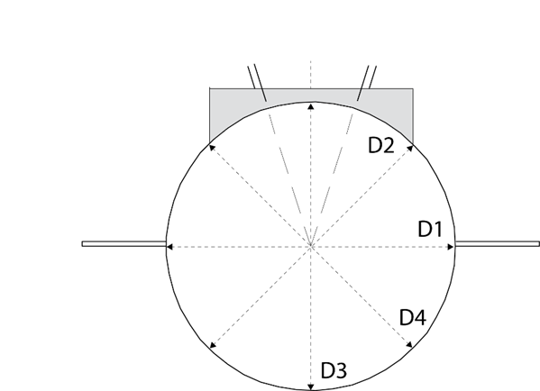

2. Facility for Discus Throw |  |  | Circle A | Circle B
Circle | The material used complies with the Rule |  | Y N | Y N
 | The top of the rim is flush with the ground outside |  | Y N | Y N
 | White lines are drawn from the top of the metal rim |  | Y N | Y N
 | Material of the interior surface:
 | The surface is level and lower than the upper edge of the rim of the circle |  | Y N | Y N
 | The rim is min. 6mm thick and is painted white |  | Y N | Y N
 | D1 | Diameter | m | m
 |  | Circle depth | m | m
 |  | Circle depth | m | m
 | D2 | Diameter | m | m
 |  | Circle depth | m | m
 |  | Circle depth | m | m
 | D3 | Diameter | m | m
 |  | Circle depth | m | m
 |  | Circle depth | m | m
 | D4 | Diameter | m | m
 |  | Circle depth | m | m
 |  | Circle depth | m | m
 | Circle depth at centre |  | m | m
Landing sector | It consists of (material):
 | The maximum overall downward inclination in the putting direction does not exceed 1:1000 |  | Y N | Y N
Provide levels at the centre of the circles (0.000m), and for the landing areas at the 30m, 50m, 70m and 80m arcs at the two sector extremities and the centreline. Depth to be provided at each end of the diameter.
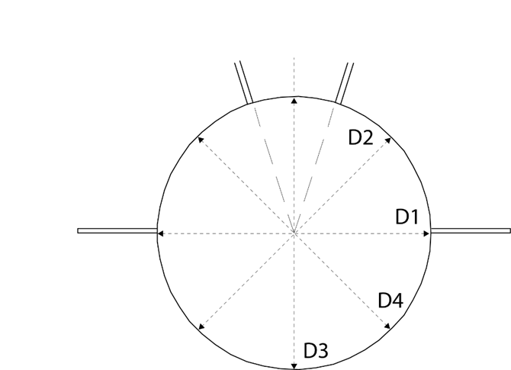

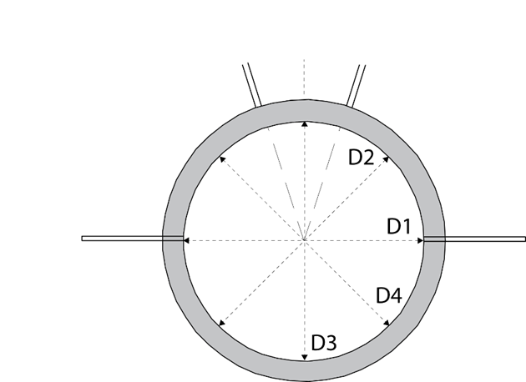
3. Facility for Hammer Throw |  |  | Circle A | Circle B
The hammer could be thrown from the discus circle provided the diameter of this circle is reduced from 2.5m to 2.135m by placing a circular ring inside.
Circle | The material used complies with the Rule |  | Y N | Y N
 | The of the rim is flush with the ground outside |  | Y N | Y N
 | White lines are drawn from the top of the metal rim |  | Y N | Y N
 | Material of the interior surface:
 | The surface is level and lower than the upper edge of the rim of the circle |  | Y N | Y N
 | The rim is min. 6mm thick and is painted white |  | Y N | Y N
 | D1 | Diameter | m | m
 |  | Circle depth | m | m
 |  | Circle depth | m | m
 | D2 | Diameter | m | m
 |  | Circle depth | m | m
 |  | Circle depth | m | m
 | D3 | Diameter | m | m
 |  | Circle depth | m | m
 |  | Circle depth | m | m
 | D4 | Diameter | m | m
 |  | Circle depth | m | m
 |  | Circle depth | m | m
 | Circle depth at centre |  | m | m
Landing sector | It consists of (material):
 | The maximum overall downward inclination in the putting direction does not exceed 1:1000 |  | Y N | Y N
Provide levels at the centre of the circles (0.000m), and for the landing areas at the 30m, 50m, 70m, 80m and 90m arcs at the two sector extremities and the centreline. (Also, for combined discus and hammer sites.) Depth to be provided at each end of the diameter.

4. Facility for Javelin Throw |  | Runway A | Runway B
Runway | Length: | m | m
 | It is marked by two parallel white lines 0.05m wide and 4m apart | Y N | Y N
 | The size and construction of the arc is in accordance with the Rules | Y N | Y N
 | To assist the officials in determining the leaving of the runway, 2 white square marks, 0.05m × 0.05m, are painted beside the runway 4 m back from the end points of the throwing arc | Y N | Y N
 | The maximum lateral inclination of the runway does not exceed 1:100 | Y N | Y N
 | In the last 20m of the runway, the overall downward inclination in the running direction is less than 1:1000 | Y N | Y N
Landing sector | It consists of (material):
 | The maximum overall downward inclination in the throwing direction does not exceed 1:1000 | Y N | Y N
Runway: Provide runway levels at the centre (0.000m) and extremities of the throwing arc, and at 20m from the throwing arc.
Landing area: Provide levels at the at the centre of the throwing arcs (0.000m), and for the landing areas at the 30m, 50m, 70m, 90m and 100m arcs at the two sector extremities and the centreline.

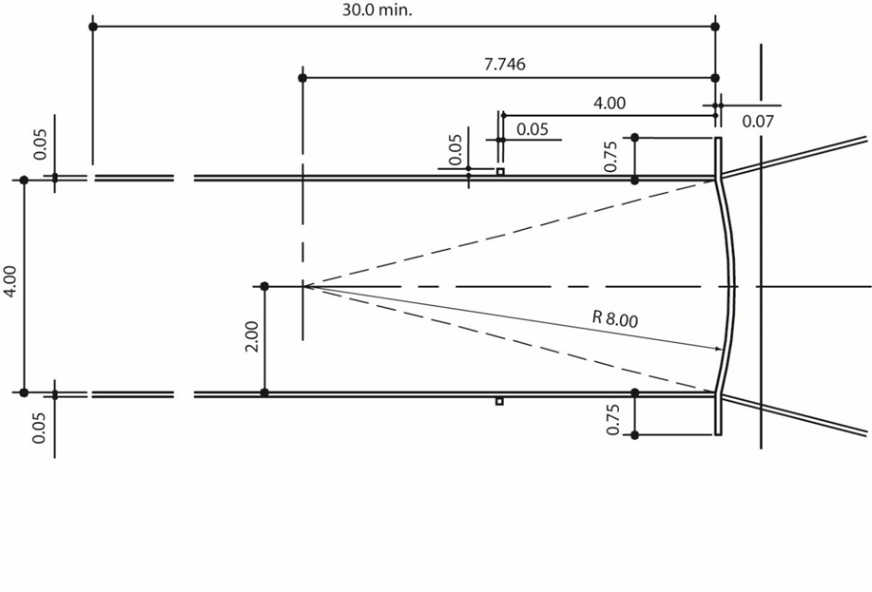

Attachments

Check mark the appropriate box below for each attachment provided with this report.

Certificates of instrument accuracy

Plan showing Field Event layouts relative to the track (layout drawing) with the facilities identified by letters and numbers which coincide with those used in the Measurement Report. Mark on the plan all the Field Event facilities built at the arena, but identify those that cannot be included in the certificate.

Levels at 200m and at the finish line on the oval track, and at the 100m and 110m start in the main straight (and second straight as well if it is part of the report)

Field Event site levels (runways and landing areas) as requested in the form

Conclusions

The competition area was checked regarding layout, gradient and dimensional accuracy.

I hereby certify that all measurements and information shown in this report are accurate and are the result of a well-conducted survey.

Considering the attached measurements made during the inspection of the facility, I recommend that the facility be granted a CLASS 2 Athletics Facility Certificate or, with a successful synthetic surface field test, a CLASS 1 Athletics Facility Certificate.

YES NO

If the answer is NO please state below the reason(s) why the facility does not come under the rules and if a Confirmation of Compliance is recommended.

Surveyor:
Date | Signature (scanned accepted)
tap to enter a date.

