REPORT
INDOOR FACILITIES MEASUREMENT

This form must be sent to: technicalofficer@worldathletics.org
together with the application for one of the following:

INDOOR Certificate
Measurement Report and current valid Product Certificate for the facility synthetic surfacing material are required.
CONFIRMATION OF COMPLIANCE
Measurement Report and the reasons why the full certification cannot be applied for are required.
Note: The technical requirements listed in the Track and Field Facilities Manual (“Manual”) on the World Athletics website also need to be met for the facility to be fit for the purpose.

NAME OF FACILITY:
City |  | Country
Address
GPS coordinates (finish line)
Latitude and longitude in decimal degree (DD) or in deg., min., sec. (DMS); elevation, if available.

SURVEY WORK
Company Name
Surveyor name |  | Email
Address
Start of survey |  | End of survey
Weather conditions |  | Temperature
Instruments
Theodolite |  | No.
Distance meter |  | No.
Last calibration date | Click or tap to enter a date.

General Notes

- For ease of distribution and handling, the report should be in Word document or pdf format. The measurements should be typed onto the form.
- Test methods are explained.
- Distances longer than 20m are to be measured by electro optical instruments.
- Angles are to be measured by theodolite.
- Provide and attach a Certificate of Instrument Accuracy for the instruments used in the survey, current at the time of the survey (less than one year old), that can be traced back to national and international standards of measurement.
- Levels to be provided in metres to three decimal places on separate forms.
- All the information required in this form must be determined by the surveyor, and he should not rely on any measurement work that may have been done by others.
- It is not for the surveyor or others to determine whether dispensations might be provided for any non-conformity with the Rules or the specification in the Manual. These are matters for World Athletics alone to determine. Certification will be delayed until the levels on the track, runways or landing areas conform. Therefore, non-conformities should be corrected before a submission is made.
- If there are more facilities than allowed for on the form, the same information as that requested should be provided for the extra facilities.
- All measurements / calculations of length must be to the nearest mm.
- No negative tolerances are allowed in the measured distance of races.
- The surveyor must report any unusual situations, not covered specifically by this proforma, that might affect the proper and safe conduct of a competition e.g. runways or track lanes which have extreme local lateral or overall inclinations, depressions or humps, bubbling or torn synthetic surface, loose or damaged kerbing etc.

GENERAL CONDITIONS

All tracks intended for use for international competition must conform to the stringent requirements for accurate measurement contained in Rules and, more specifically, in the Track and Field Facilities Manual.
The Measurement Report duly completed by a fully qualified surveyor is one of the requirements to issue an Indoor Athletic Facility Certificate.
Application for an Athletic Facility Certification may be made by an agent on behalf of the track owner but should be signed by the track owner as World Athletics will require an undertaking that any changes, (relining etc.) will be immediately notified to the Office.
Certificates issued under this scheme will normally be valid for five years. In the event of track remarking, World Athletics shall be informed, and a new Measurement Report must be provided.
Demountable facilities must be re-measured before each competition and after records.
All removable competition equipment such as hurdles, landing mats, stop boards, protective cages have to be inspected before a competition and are not part of this Report. The same applies to the level of the sand in the horizontal jump landing pits.

OWNER OF FACILITY/STADIUM:
Address
City |  | Country
Email |  | Tel
Signature (scanned accepted) |  | Date | Click or tap to enter a date.

CONTENTS

General Notes 2

GENERAL CONDITIONS 2

CONTENTS 3

FACILITY 4
A. Construction Category 4
1. Competition Arena 4
2. Warm-up Area 4

TRACK EVENTS 5
B. 200m Standard Track and Sprint Straight Track 5
1. Oval Track 5
2. Sprint Straight Track 5
3. Track and Runway Surface (including sprint straight track) 6
4. Length of the Track 7
5. The Incline of the Track 11
6. International Markings on the Track 12

FIELD EVENTS 16
C. Facilities for Jumping Events 16
1. Facility for High Jump 16
2. Facility for Pole Vault 16
3. Facility for Long Jump 17
4. Facility for Triple Jump 17
D. Facilities for Throwing Events 18
1. Facility for Shot Put 18
E. Attachments 19
F. Conclusions 19

FACILITY

Construction Category

1. Competition Arena
Provide a layout drawing and photo of the facility in attachment. For determining the Construction Category, a single runway would normally have landing areas or Pole Vault boxes at each end or at the centre. Based on the below information, the Construction Category will be determined during the review of the Measurement Report. Write the number of event facilities in the boxes below.
200m Standard Track |  | Y N | Other | m
Number of oval lanes |  |  | Number of sprint straight lanes
Facility for Long and Triple Jump
Facility for High Jump
Facility for Pole Vault
Facility for Shot Put
Permanent ancillary space at the competition arena  (e.g. for conditioning, physiotherapy, resting of athletes (Manual Chapter 8)) |  |  |  | m²
Full facilities for spectators (Indicate the number of spectators fully catered for)
Notes

2. Warm-up Area
Warm-up track provided |  |  |  |  |  | Y N
Surface of similar type to the main track |  |  |  |  |  | Y N
Track length m |  | No. of oval/straight lanes |  |  | o/ s
Jumping events HJ |  | PV |  | LJ | TJ
Shot Put
If there is no warm-up track, is an area for warm up available? |  |  |  |  |  | Y N
If yes, size, indoor and/or outdoor, surface
Permanent ancillary space at the warm up |  |  |  |  |  | m²
Notes

TRACK EVENTS

200m Standard Track and Sprint Straight Track

1. Oval Track

1.1 Description
Type of construction:
Track is: demountable |  |  | permanent |  | The banking is: of fixed slope |  |  | of adjustable slope
Type of transitions:
multiple radii |  |  | clothoid |  | no horizontal transitions |  |  | other:

1.2 Dimensions
Inner Kerb |  | Y N |  | Height |  | m |  |  | Width | m
Kind of inner edge (e.g. alu, plastic) |  |  |  |  |  | Radius of kerb or inside white line edge |  |  |  | m
Distance between centre points |  |  |  | m |  | Distance between two straights |  |  |  | m
Horizontal angle of constant banked track (α) |  |  |  | gon |  | Maximum vertical angle of banking |  |  |  | ⁰
Length of straights on the oval |  |  |  | m |  | Length of transition at kerb or inside line |  |  |  | m
Length of construction at kerb or inside white line edge (planning size) |  |  |  |  |  |  |  |  |  | m
Number of oval lanes: |  |  |  |  |  | Width of lanes (planning size) |  |  |  | m
The line on the right-hand side of each lane, in the direction of running, is included in the measurement of the width of each lane.
Width of the track (planning size) |  |  |  |  |  |  |  |  |  | m
One finish line for all oval events |  |  |  | Y N |  | Location
Safety zone inside |  |  |  | m |  | Safety zone outside |  |  |  | m
Distance from banked outside lane to safety fence |  |  |  |  |  |  |  |  |  | m
Notes

2. Sprint Straight Track

2.1 Dimensions
Length of construction (planning size) |  | m |  | Number of lanes
Width of lanes (planning size) |  | m |  | Width of the track (planning size) |  |  | m
Safety zone left hand side |  | m |  | Safety zone right hand side |  |  | m
Clearance behind the start line |  |  |  |  |  |  | m
Outrun after the finish line |  |  | Flat |  | m | Oval track | m
Overrun safety mats |  |  |  |  |  |  | Y N
Notes

3. Track and Runway Surface (including sprint straight track)
See list : https://www.worldathletics.org/about-iaaf/documents/technical-information
Track surface product name |  |  |  | synthetic |  | other
Name of manufacturer
Certification number if applicable
Absolute thickness |  | Oval | mm | Straight | mm | Runways | mm
Installation company
Address
Date of installation |  |  |  | Email
Line marking company
Line marker’s name |  |  |  | Date of marking
Notes

4. Length of the Track
Provide a plan showing set-out dimensions and angles

4.1. Dimensional Accuracy of the 200m Standard Track
The dimensional accuracy required for all classes of competition is measured in the 25 Point Control readings on the running line of each lane. The running line is 300mm out from any kerb or 200mm out from the outside edge of any painted lane marking. When curve lengths are measured by steel tape then the running line shall be defined by nails placed at not greater than 300mm centres. The constant bank bends may be measured by radial measures as indicated below.
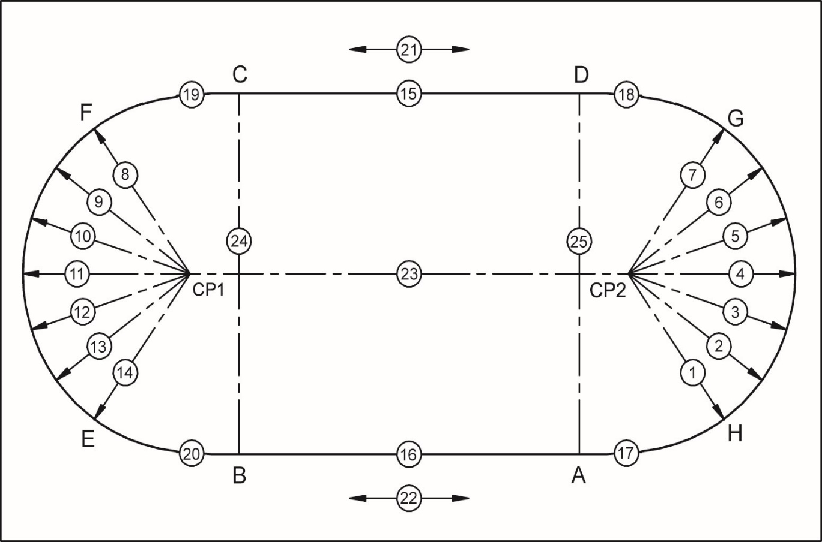.

Record of 25 point control measurement:
(All measurements shall be in metres to three decimal places.)

L= Measured length of radii 1-7 and 8-14 to each lane running lines of constant banked track
R= Desired length of radii for each lane running line ( R₁, R₂, R₃, …)
S= Measured length of the straights 15 and 16 (along each lane running line)
M= Desired length of each straight: m
U= Measured length of the ascending / descending track 17, 18, 19 and 20 (along each lane running line)
T= Desired length for the ascending / descending track: m
D= Deviation from desired value in millimetres (L-R), (S-M), (U-T)
A= Measurements 21 and 22: alignment of the straights (the measured length of the straight at the kerb or inside white line edge compared with the measurement at the outside edge of the outer lane)

Permitted deviation from desired value for 1-20 and 23-25: 0.005m
Permitted deviation from alignment for 21 and 22: 0.01m
Permitted tolerance of the running length: +0.040m max.

N° | Angle | Lane 1 |  | Lane 2 |  | Lane 3 |  | Lane 4 |  | Lane 5 |  | Lane 6
 |  | R₁ = m |  | R₂ = m |  | R₃ = m |  | R₄ = m |  | R₅ = m |  | R₆ = m
 |  | L | D | L | D | L | D | L | D | L | D | L | D
 | gon | m | mm | m | mm | m | mm | m | mm | m | mm | m | mm
1
2
3
4
5
6
7
Averaged | 1-7
Bend length*
8
9
10
11
12
13
14
Averaged | 8-14
Bend length*

* average L × π × α / 200 (Value of π computer generated.)
The bend average radii shall be calculated to four decimal places.
If any “D” value exceeds ± 5mm then the lane width should be checked to ensure that it is the nominal width ± 0.01m.
15 | S
16 | S
17 | U
18 | U
19 | U
20 | U
21 | A
22 | A
23 | CP1-CP2
24 | B-C
25 | A-D

4.2. Calculation of the Lane 1 Running Line Length

Length
The bend lengths and length deviations shall be calculated to three decimal places using bend average radii and differences to four decimal places.
Lane 1 | Radial Measure | Angle | Length
Average radius curve H - G | m | gon | m (+)
Average radius curve F - E | m | gon | m (+)
Straight C – D (15) | n/a | n/a | m (+)
Straight A – B (16) | n/a | n/a | m (+)
Transition H – A (17) | n/a | n/a | m (+)
Transition D – G (18) | n/a | n/a | m (+)
Transition F – C (19) | n/a | n/a | m (+)
Transition B – E (20) | n/a | n/a | m (+)
Length of the lane 1 running line | n/a | n/a | m (=)

Deviation from the running length
Lane 1 | Radial Measure Deviation | Angle | Length Deviation
Average deviation from desired value H - G | m | gon | m (+)
Average deviation from desired value F - E | m | gon | m (+)
Straight C – D (15) | n/a | n/a | m (+)
Straight A – B (16) | n/a | n/a | m (+)
Transition H – A (17) | n/a | n/a | m (+)
Transition D – G (18) | n/a | n/a | m (+)
Transition F – C (19) | n/a | n/a | m (+)
Transition B – E (20) | n/a | n/a | m (+)
Length of the lane 1 running line | n/a | n/a | m (=)

4.3 Certification of the Length
The control of the inside lane running line length of track gives a length greater than 200m | Y N
The calculated difference of m (TRD-200m) is inside the permitted tolerance of +0.040m laid down in the Manual | Y N
The measurement of lane one was taken 0.30 metres outward from the kerb / 0.20 metres outward from the painted line | Y N
The running line lengths of the other lanes were calculated at 0.20 metres outward from the outer edges of the lines | Y N
Direction of running is left-hand inside. Lanes are numbered with the left hand inside lane as 1 | Y N

5. The Incline of the Track

5.1 Banked Bends Inclination

The incline of the banked bends shall be determined by measuring the difference in height at the kerb or painted line and the outside of the outside lane.

No. | Angle | Design Width | Measured Width of Bank | Height Lane1 Inside | Height Outside Lane | Difference in Height | Angle  Degrees
 |  |  | x |  |  | y | tan⁻¹(y/x)
1 | gon | m | m | m | m | m | ⁰
2 | gon | m | m | m | m | m | ⁰
3 | gon | m | m | m | m | m | ⁰
4 | gon | m | m | m | m | m | ⁰
5 | gon | m | m | m | m | m | ⁰
6 | gon | m | m | m | m | m | ⁰
7 | gon | m | m | m | m | m | ⁰
Av. 1-7 | n/a | n/a | m |  |  |  | ⁰
Deviation | n/a | n/a | m | n/a | n/a | n/a | ⁰
8 | gon | m | m | m | m | m | ⁰
9 | gon | m | m | m | m | m | ⁰
10 | gon | m | m | m | m | m | ⁰
11 | gon | m | m | m | m | m | ⁰
12 | gon | m | m | m | m | m | ⁰
13 | gon | m | m | m | m | m | ⁰
14 | gon | m | m | m | m | m | ⁰
Av. 8-14 | n/a | n/a | m | m | m | m | ⁰
Deviation | n/a | n/a | m | n/a | n/a | n/a | ⁰

5.2 Incline of the Oval Track

The inside edge of the kerb or line (or the pivot point of the banking) is horizontal throughout the length of the track | Y N
The straight is flat or has a maximum lateral inclination of 1:100 (1%) towards inside | Y N

5.3 Incline of the Sprint Straight Track
The lateral inclination of the track is less than 1:100 (1%) and the overall inclination from the start(s) to the finish line is less than 1:1000 (0.1%) | Y N

The sign convention for World Athletics for the inclinations is that an upward inclination in the direction of running is positive.

Notes

6. International Markings on the Track

6.1 General
All lanes are marked by white lines |  | Y N
All markings are 0.05m wide |  | Y N
All start lines (except for curved start lines) and the finish line are marked at right angles to the lane lines |  | Y N
The staggered starts for 800m events are marked so that the first or second bend has to be run in separate lanes. (The position of the start lines and the arced green breakline, 0.05m wide, at the beginning of the following straight or the second straight, respectively, are as given in the Manual.) |  | Y N
The 4 tangent points on the 2 straights and the intersection of different radii curves are marked in a distinctive colour 0.05m × 0.05m on the white line of the inner lane |  | Y N
The 4 × 800m, 4 × 400m and 4 × 200m start lines are in accordance with the Manual (cf. 5.5 International Relay Races) |  | Y N
The intersection of lane lines and finish line is painted black in a suitable design to assist alignment of the Photo Finish equipment and to facilitate the reading of the Photo Finish image |  | Y N
Immediately before the finish line, the lanes are marked with numbers with a minimum height of 0.50m read in the direction of running or from the outside of the track (optional) with the left-hand inside lane numbered 1 |  | Y N
White lines, 0.03m wide and 0.80m (0.40m at 2m) long, are marked 1m, 3m and 5m before the finish line (optional) |  | Y N
Notes

6.2 International Starts
The following international starts are marked on the track:

Races entirely or partly in separate lanes
50m | white | straight | in separate lanes | Y N
60m |  |  |  | Y N
200m |  | oval |  | Y N
400m |  |  | two bends in separate lanes | Y N
800m | white / green /white |  | first bend in separate lanes | Y N
4 × 200m | white / light blue / white |  | three bends in separate lanes | Y N
4 × 400m | yellow / white / yellow |  | two bends in separate lanes | Y N

Curved starts
800m | white | 4 full laps | Y N
1500m |  | 7 full laps + 100m | Y N
3,000m |  | 15 full laps | Y N

6.3 Start Measurement
All measurements shall be in metres (m) to three decimal places.
No negative tolerances are allowed in the measured distance of races. The deviation from the running length of all start lines must not exceed +0.0001 × L nor be less than 0.000m where L is the length of the race in metres.

All distances were measured in a clockwise direction from the edge of the finish line nearer to the start to the edge of the start line farther from the finish | Y N
The measurement of the curved start lines ensures that all runners start the same distance from the finish | Y N

Measured Distance to Finish Line
Start | Lane 1 | Lane 2 | Lane 3 | Lane 4 | Lane 5 | Lane 6 | Lane 7 | Lane 8 | (Lane 9)
50m
60m
200m |  |  |  |  |  |  | n/a | n/a | n/a
400m |  |  |  |  |  |  | n/a | n/a | n/a
800m |  |  |  |  |  |  | n/a | n/a | n/a
4 x 200m |  |  |  |  |  |  | n/a | n/a | n/a
4 × 400m |  |  |  |  |  |  | n/a | n/a | n/a

Measured Distance to Finish Line First Lap
Curved Start | Lane 1 | Lane 2 | Lane 3 | Lane 4 | Lane 5 | Lane 6
1500m
3000m
800m

Notes

6.4 International Hurdle Events
Direction of running

The distances between the hurdles are measured from front to front of the marker.
For blue marks on blue coloured tracks, red colour should be used.

The following hurdle events are marked on the track and the measured distances to Finish Line (m):
Tolerance on hurdle distances ± 0.01.
 | 5th | 4th | 3rd | 2nd | 1st
50m Men*
60m Men
50m Women*
60m Women

50/60m Hurdles (Men) | Green/blue** rectangle | 0.10m × 0.05m | Y N
50/60m Hurdles (Women) | Orange/yellow rectangle | 0.10m × 0.05m | Y N
*The 50m marks are optional if there is 60m marked

There are five/four flights of hurdles marked in each lane. The distances between the hurdles in each lane are in accordance with the table in the Rule | Y N
The markings are on the left and right side in each lane. Markings, sizes and colours are in accordance with the Manual Marking Plan | Y N

Notes

6.5 International Relay Races
The following international relays are marked on the track and the measured distances to the finish are (m):
For blue marks on blue coloured tracks, red colour should be used.

4 × 200m Relay - Measured Distance to Finish
Takeover zone length 20m ± 0.02m, with the scratch line 10m from the start of the zone.
The 2nd runner middle (scratch line) corresponds with the 800m start in each lane. For ease of compilation and checking, these measures may also be quoted as 800m measures.
Takeover zone |  | Lane 1 | Lane 2 | Lane 3 | Lane 4 | Lane 5 | Lane 6
2nd runner | End: yellow line
 | Middle: white/green/white
 | Start: yellow line

All the first leg (first runner) and the first bend of the second leg (second runner) is run in separate lanes up to the breakline marked at the end of the first bend | Y N
The dimensions of the relay takeover zones are in accordance with the rule | Y N
Marking sizes and colours are in accordance with the Manual Marking Plan | Y N

4 × 400m Relay
Takeover zone length 20m ± 0.02m, with the scratch line 10m from the start of the zone.
The scratch line corresponds with the finish line.
The first leg runner starts and continues in separate lanes up to the breakline marked at the end of the second bend (as for the individual 400m) | Y N
The dimensions of the relay takeover zones are in accordance with the rule | Y N
Marking sizes and colours are in accordance with the Manual Marking Plan | Y N

Notes

FIELD EVENTS

Please use separate drawings (proformas to be used are available on the website) for providing the required spot levels. The Field Event facilities shall be identified by letters and numbers which coincide with those used in the Measurement Report and on the site plan for those facilities.
Provide reduced levels not grades on each of the runways at the intervals as requested on the proforma including all the take-off board(s), landing areas and at the planter boxes as appropriate.
For ease of checking, it will assist if the level on the pole vault box, take-off and throws circle is assumed to be 0.000m.
The sign convention used by World Athletics for inclinations is that an upward inclination in the direction of running or throwing is positive. (For throws, at any radius, the lowest level is compared with the level at the centre of the appropriate throwing circle or javelin throwing arc to determine the inclination.)

Facilities for Jumping Events

1. Facility for High Jump |  | Area A | Area B
Runway | Length (m)
 | Does this length include part of the track? | Y N | Y N
Take-off area | It is level or the inclination complies with the rule | Y N | Y N
Inclination | The maximum overall inclination in the last 15m of the runway and take-off area is less than 1:167 (0.6%) in the direction of the centre of the crossbar | Y N | Y N
Provide runway radial levels at the centre of the take offs (0.000m) and 15m from the centre of each High Jump take off.

2. Facility for Pole Vault |  | Area A1 | Area A2
Runway | Length (m)
 | Width (m)
 | It is marked by white lines 0.05m in width | Y N | Y N
 | There are marks beside the runway at each 0.5m between points 2.5m to 5m from the “0” line and at each 1m from 5m to 18m | Y N | Y N
Inclination | The maximum lateral inclination of the runway is less than 1:100 | Y N | Y N
 | In the last 40m of the runway, the overall downward inclination in the running direction is less than 1:1000 | Y N | Y N
Pole Vault box | Size, material and construction are in accordance with the rule | Y N | Y N
Zero line | A white line, 0.01m wide, is drawn at right angles to the axis of the runway, in line with the top back end of the box | Y N | Y N
Provide runway levels at the box (0.000m) and 10m intervals from each Pole Vault box.

3. Facility for Long Jump |  | Area A1 | Area A2
Runway | Length (m)
 | Width (m)
 | It is marked by white lines 0.05m in width | Y N | Y N
Inclination | The maximum lateral inclination of the runway is less than 1:100 | Y N | Y N
 | In the last 40m of the runway, the overall downward inclination in the running direction is less than 1:1000 | Y N | Y N
Take-off board | It is in accordance with the rule | Y N | Y N
 | Distance between the take-off line and the far end of the landing area (m)
 | Distance between the take-off line and the nearer end of the landing area (m)
Landing area | Total width (m):
 | The axis of the runway is in line with the centre line of the landing area | Y N | Y N
Provide levels at each take-off board (0.000m), 40m from each Long Jump take-off board and at the landing area kerb four corners. If there are multiple horizontal jump runways using a common landing area that must have temporary taping during competition to limit the landing area width to 3.00m maximum, then additional levels shall be provided where the temporary taping will intersect the landing area surround.

4. Facility for Triple Jump |  |  | Area A1 | Area A2
Runway | Length (m) | Men
 |  | Women
 | Width (m)
 | It is marked by white lines 0.05m in width |  | Y N | Y N
Inclination | The maximum lateral inclination of the runway is less than 1:100 |  | Y N | Y N
 | In the last 40m of the runway, the overall downward inclination in the running direction is less than 1:1000 |  | Y N | Y N
Take-off board | It is in accordance with the rule |  | Y N | Y N
 | Distance between the take-off line and far end of the landing area (m) | Men
 |  | Women
 | Distance between the take-off line and the nearer end of the landing area (m) | Men
 |  | Women
Landing area | Total width (m)
 | The depth Is not less than 30cm |  | Y N | Y N
 | The axis of the runway is in line with the centre line of the landing area. |  | Y N | Y N
Provide levels as at Long Jump. Please use a separate form for each Triple Jump board.

Facilities for Throwing Events

1. Facility for Shot Put
Circle | The material complies with the rule |  | Y N
 | The top of the rim is flush with the ground outside |  | Y N
 | White lines (min. 0.75m) are drawn from the top of the rim |  | Y N
 | Interior surface (material)
 | Surface is level and lower than upper edge of rim |  | Y N
 | The metal rim is min. 6mm thick and is painted white |  | Y N
 | D1  Depth to be provided at each end of the diameter | Diameter | m
 |  | Depth | m
 |  | Depth | m
 | D2 | Diameter | m
 |  | Depth | m
 |  | Depth | m
 | D3 | Diameter | m
 |  | Depth | m
 |  | Depth | m
 | D4 | Diameter | m
 |  | Depth | m
 |  | Depth | m
 | Depth at centre |  | m
Landing sector | It consists of (material):
 | Stop barriers comply with the rule |  | Y N
 | The maximum overall downward inclination in the putting direction does not exceed 1:1000. |  | Y N
Provide levels at the centre of the circles (0.000m), and for the landing areas at the 10m, 15m, 20m and 25m arcs at the two sector extremities and the centreline.
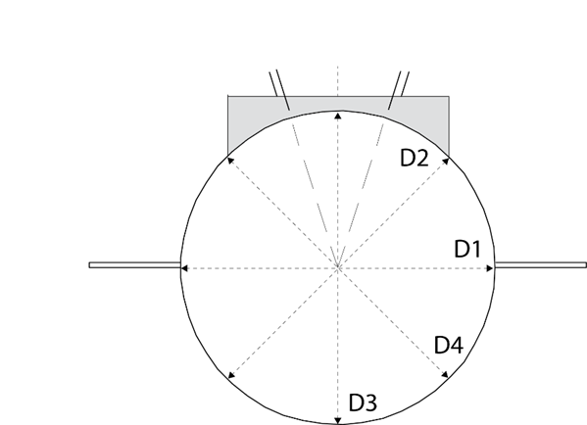
The stop board must be checked before a competition.

Attachments

Check mark the appropriate box below for each attachment provided with this report

Certificates of instrument accuracy

Plan showing set-out dimensions and angles and Field Event layouts relative to the track (layout drawing) with the facilities identified by letters and numbers which coincide with those used in the Measurement Report.

A dimensioned sketch of the Shot Put site including the landing area stop barrier

Levels at the finish line on the sprint straight, and at the 50m and 60m start

Field Event site levels (runways and landing areas) as requested in the form

Conclusions

The competition area was checked regarding layout, gradient and dimensional accuracy.

I hereby certify that all measurements and information shown in this report are accurate and are the result of a well-conducted survey.

Considering the attached measurements made during the inspection of the facility, I recommend that the facility be granted an Indoor Athletics Facility Certificate.

YES NO

If the answer is NO please state below the reason(s) why the facility does not come under the rules and if a Confirmation of Compliance is recommended.

Notes

Surveyor:
Date | Signature (scanned accepted)
tap to enter a date.

